Date 18-08-2021

* Joins – LEFT JOIN, RIGHT JOIN,,FULL JOIN, FULL OUTER JOIN , INNER JOIN

SELECT *

FROM hr.candidates c

INNER JOIN hr.employee e

ON e.fullname = c.fullname;

SELECT *

FROM hr.candidates c

FULL JOIN hr.employee e

ON e.fullname = c.fullname;

SELECT *

FROM hr.candidates c

FULL OUTER JOIN hr.employee e

ON e.fullname = c.fullname;

SELECT *

FROM hr.candidates c

RIGHT JOIN hr.employee e

ON e.fullname = c.fullname;

SELECT *

FROM hr.candidates c

LEFT JOIN hr.employee e

ON e.fullname = c.fullname;

SELECT *

FROM hr.candidates c

CROSS JOIN hr.employee e

ON e.fullname = c.fullname;

* GROUP BY ,HAVING :-

SELECT ( first_name )first_name,

Max(phone) phone_number

FROM sales.customers c

GROUP BY phone

HAVING phone IS NULL

* CUBE :-

SELECT

brand,

category,

SUM (sales) sales

FROM

sales.sales_summary

GROUP BY

CUBE(brand, category);

* ROLL UP :-

SELECT

brand,

category,

SUM (sales) sales

FROM

sales.sales_summary

GROUP BY

ROLLUP(brand, category);

* SUB QUERY :-

SELECT

order_id,

order_date,

customer_id

FROM

sales.orders

WHERE

customer_id IN (

SELECT

customer_id

FROM

sales.customers

WHERE

city = 'New York'

)

ORDER BY

order_date DESC;

* CORRELATED SUBQUERY :

SELECT

product_name,

list_price,

category_id

FROM

production.products p1

WHERE

list_price IN (

SELECT

MAX (p2.list_price)

FROM

production.products p2

WHERE

p2.category_id = p1.category_id

GROUP BY

p2.category_id

)

ORDER BY

category_id,

product_name;

* Exists: -

SELECT

customer_id,

first_name,

last_name

FROM

sales.customers

WHERE

EXISTS (SELECT NULL)

ORDER BY

first_name,

last_name;

* ANY :-

SELECT

product_name,

list_price

FROM

production.products

WHERE

product_id = ANY (

SELECT

product_id

FROM

sales.order_items

WHERE

quantity >= 2

)

ORDER BY

product_name;

* INTERSECT :-

SELECT

city

FROM

sales.customers

INTERSECT

SELECT

city

FROM

sales.stores

ORDER BY

city;

* Creating new database called Online_shopping_System
* Creating tables

CREATE TABLE customer

(

customer_id INT PRIMARY KEY IDENTITY (1, 1),

NAME VARCHAR(255),

contact_add INT,

address TEXT

);

CREATE TABLE categories

(

category_id INT PRIMARY KEY IDENTITY (1, 1),

category_name VARCHAR(255),

category_type VARCHAR(255)

);

CREATE TABLE shoppingorder

(

order_id INT PRIMARY KEY IDENTITY (1, 1),

customer_id INT

CONSTRAINT fk_group FOREIGN KEY (customer_id) REFERENCES customer(

customer_id),

date DATE

);

CREATE TABLE deliveries

(

acc_id INT PRIMARY KEY IDENTITY (1, 1),

customer_id INT

CONSTRAINT fk_deliveries FOREIGN KEY (customer_id) REFERENCES customer

(

customer_id),

date DATE

);

CREATE TABLE products

(

product_id INT PRIMARY KEY IDENTITY (1, 1),

category_id INT

CONSTRAINT fk_products FOREIGN KEY (category_id) REFERENCES categories

(

category_id),

product_name VARCHAR(255)

);

CREATE TABLE seller

(

seller_id INT PRIMARY KEY IDENTITY (1, 1),

product_id INT

CONSTRAINT fk_seller FOREIGN KEY (product_id) REFERENCES products(

product_id),

seller_name VARCHAR(255)

);

CREATE TABLE payment

(

payment_id INT PRIMARY KEY IDENTITY (1, 1),

customer_id INT

CONSTRAINT fk_payment FOREIGN KEY (customer_id) REFERENCES customer(

customer_id),

date DATE

);

CREATE TABLE transaction_report

(

report_id INT PRIMARY KEY IDENTITY (1, 1),

customer_id INT

CONSTRAINT fk_transaction FOREIGN KEY (customer_id) REFERENCES

customer(

customer_id),

order_id INT

CONSTRAINT fk_order FOREIGN KEY (order_id) REFERENCES shoppingorder(

order_id),

product_id INT

CONSTRAINT fk_pro FOREIGN KEY (product_id) REFERENCES products(

product_id),

payment_id INT

CONSTRAINT fk_pay FOREIGN KEY (payment_id) REFERENCES payment(payment_id)

);

* 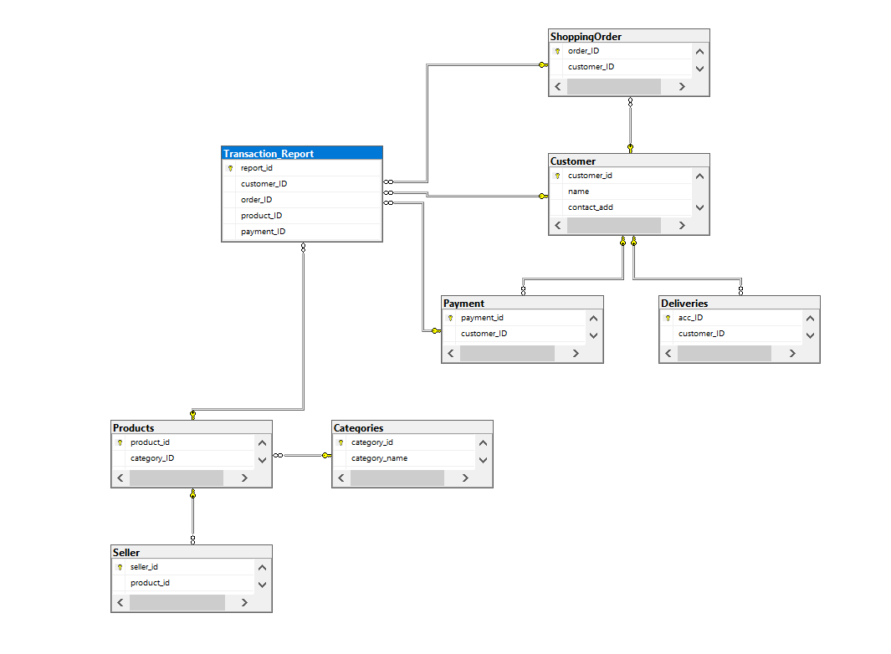ER diagram of Online_shopping_system :-